IoT Factory Documentation

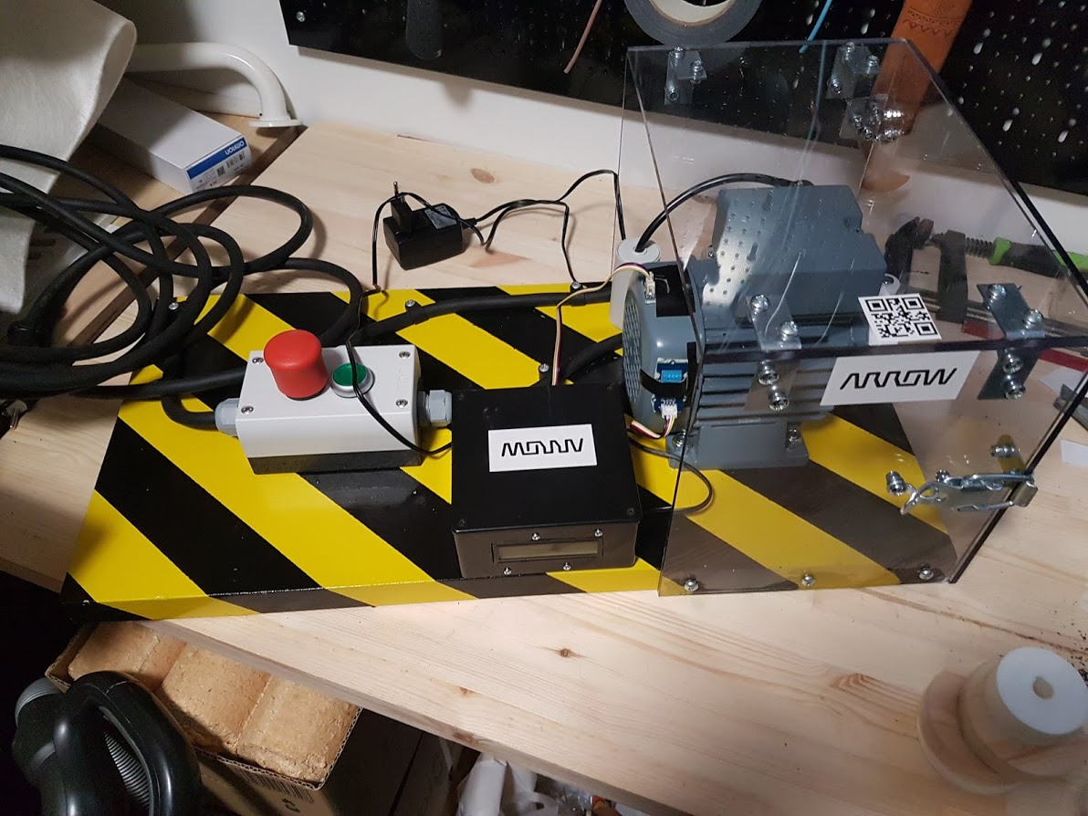

Tuukka Korhonen

Cloud Architect

Arrow ECS Finland

Table of Contents

Part List 3

Wooden board preparation 4

Electrical wiring 5

Motor enclosure 6

Raspberry enclosure 7

Raspberry and sensor connections 9

Wooden board layout 9

Pulleys 11

Raspberry image 11

Set Up Azure IoT Central & Create a New Device 14

Attachments 17

Version history 17

# Part List

* 1 pcs wood board 300mm x 600mm x 28 mm (pine plate)
* 1 electrical motor VEM K21R 63 K2
* 1 running condenser with cable 14uF
* 4 pcs bolt M8 300 mm plus locknuts and split lock washer (for mounting motor)
* 32 pcs M5 ~12 mm plus locknuts and washers (for hinge, angle irons and lock hatch)
* 6 pcs wood screws 5 mm x 300 mm to mount motor enclosure
* 2 pcs ~4 mm x ~500 mm long wood screws to mount safety switch with roller
* 2 pcs ~4 mm x ~200 mm wood screws to mount raspberry enclosure to wooden board (flat head)
* 2 pcs ~4 mm x ~200 mm wood screws to mount switchbox to wooden board
* 6 pcs screw clips for mounting electrical cord to wood board
* 1 electrical plug for main power cable
* 4 pcs cable gland (ST-M20x1,5)
* 3 pcs lock nut for cable gland (GMP-GL M20x1,5)
* 1 pcs METAL cable gland (ST-M20x1,5, for motor)
* 1 pcs plastic enclosure (m22-I2, switch box)
* 2 pcs contact block (M22-KC10)
* 2 pcs contact block (M22-KC01)
* 1 pcs green led block (M22-LEDC230-G)
* 1 pcs on/off switch with green button cover (M22-DRL-X)
* 1 pcs emergency stop switch (M22-PVT)
* 1 pcs safety switch with roller (D4B-4116N)
* 2 pcs hinge (40x40x40, six screw holes)
* 4 pcs angle iron (40x40x20)
* 1 pcs lock latch ~50x20
* 4 meters of flexible electrical cord (3 x 2,5 mm)
* Heat shrink and cable connects to connect wires to motor and safety switch
* Primer spray paint
* Yellow spray paint
* Black spray paint
* Lacker spray
* 1 pcs polycarbonate clear plate D: 200 mm x W: 310 mm x 5 mm (top)
* 2 pcs polycarbonate clear plate W: 200 mm x H: 230 mm x 5 mm (sides)
* 1 pcs polycarbonate clear plate W: 310 x H: 235 mm x 5 mm (door)
* Raspberry plastic enclosure 120x120x60 (1591-USBK)
* Bolts and nuts for mounting Raspberry and LED-display M2.5 x 12, M2.5 x 20
* 3 pcs 3D printed plastic pulleys (use stl files)
* 1 pcs raspberry PI 3 MODEL B with power supply
* GrovePi+ sensor board for rasbpberry Pi (SKU 103010002)
* Grove - 3 Axis Digital Accelerometer(±16g) plus connecting cable (SKU 101020054)
* Grove - Temperature&Humidity Sensor Pro plus connecting cable (SKU 101020011)
* Grove - LCD RGB Backlight plus connecting cable (SKU 104030001)
* QR-code for motor ID (QR code should read IE3-W42R63K2)
* Cell rubber mat with adhesive 300 mm x 600 mm x 5 mm

# Wooden board preparation

1. Measure and drill 8 mm holes for motor mounting (see board layout and mark the holes)
2. Make hollow cuts under the board to accommodate bolt heads ~18 mm deep and ~25 mm diameter
3. Grind wooden board saw cuts (better paint coverage)
4. Paint with primer 2-3 coats (2 hours to dry between coats)
5. Paint with yellow 2-3 coats (2 hours to dry between coats)
6. Use masking tape to make stripes (let dry over night before taping)
7. Paint with black 2-3 coats (2 hours to dry between coats)
8. Paint with lacker 2-3 coats (2 hours to dry between coats)
9. Let dry over night before mounting motor and components

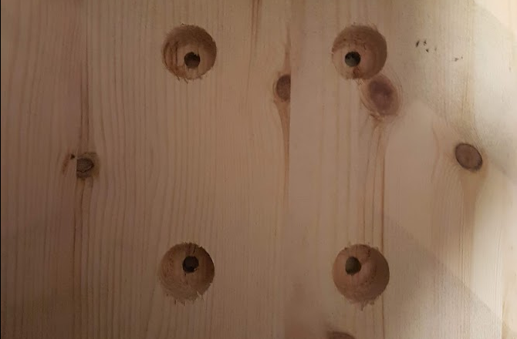

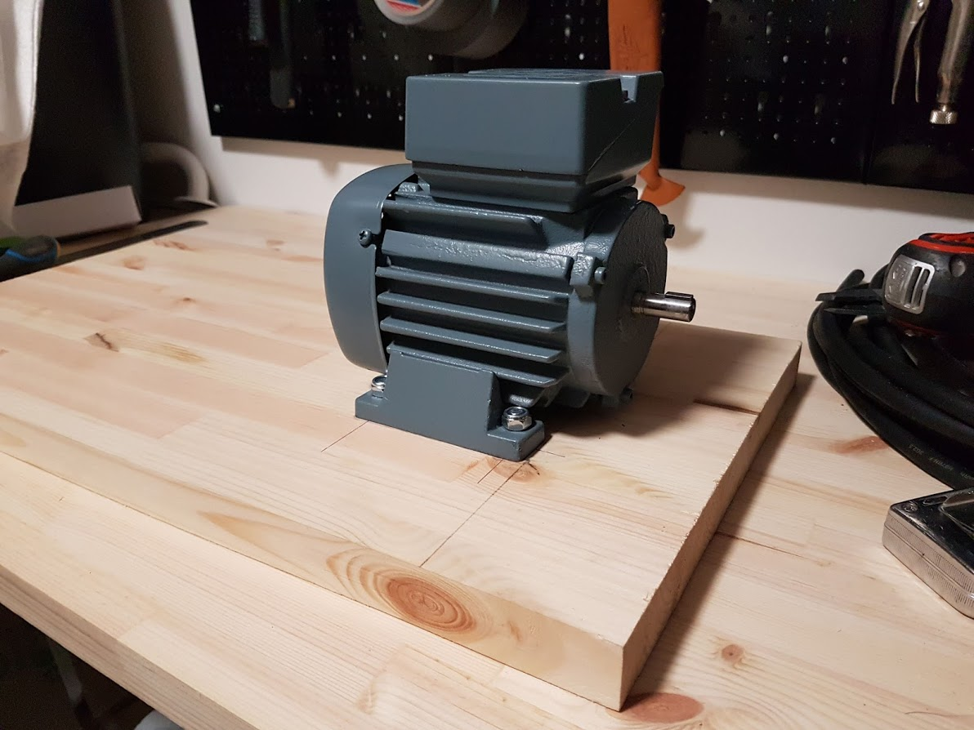

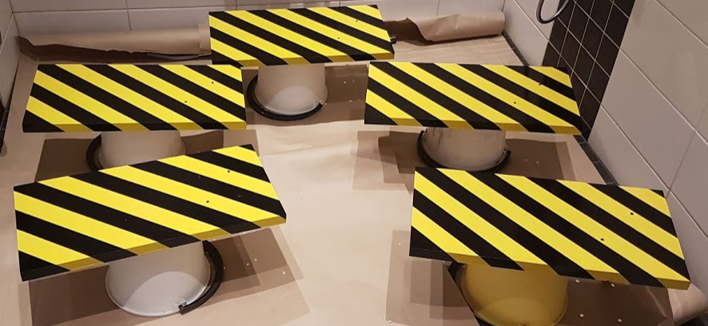

# Electrical wiring

Connect motor with delta connection. We are using 1 phase current and we need a condenser to get the motor running.

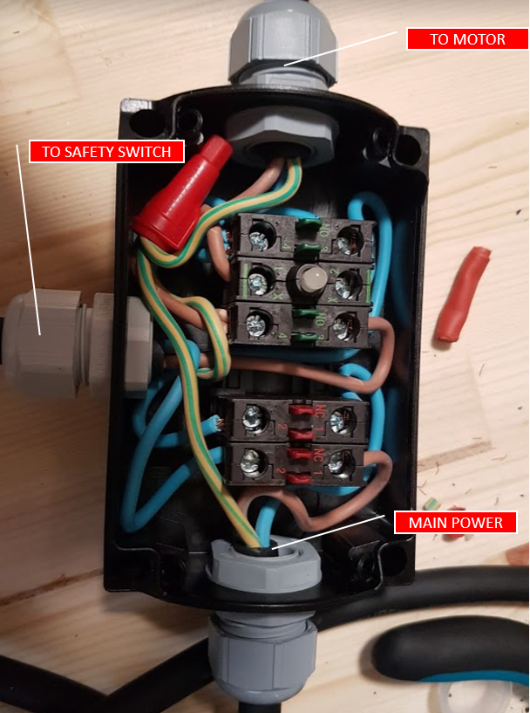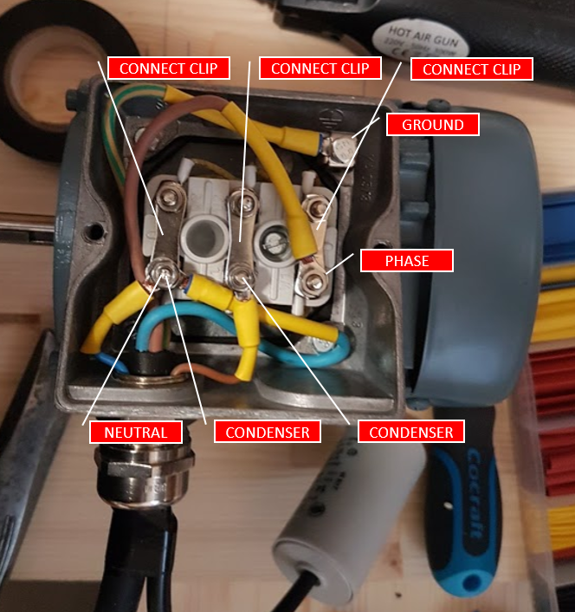

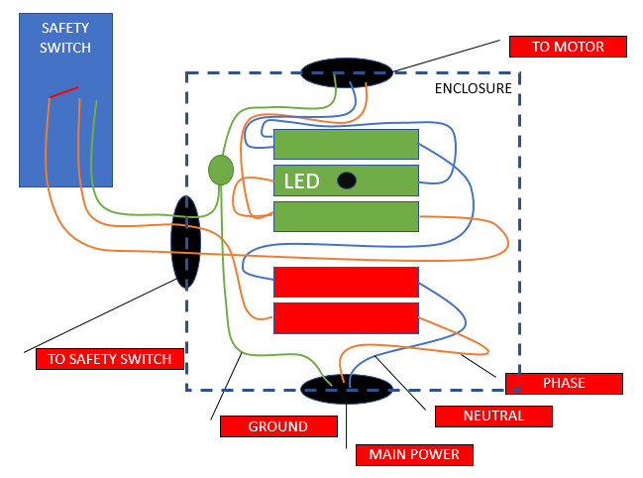

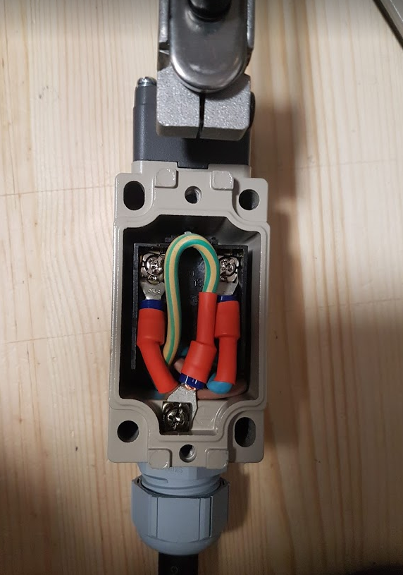

# Motor enclosure

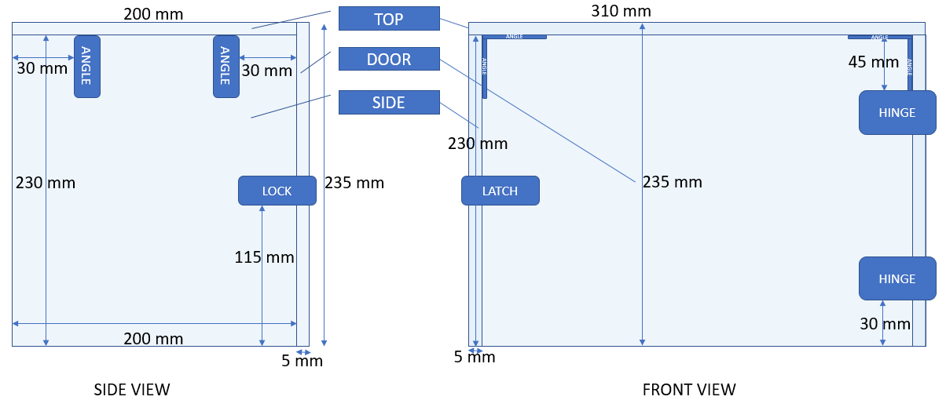Mark the holes and drill 6 mm holes if using 5 mm bolts.

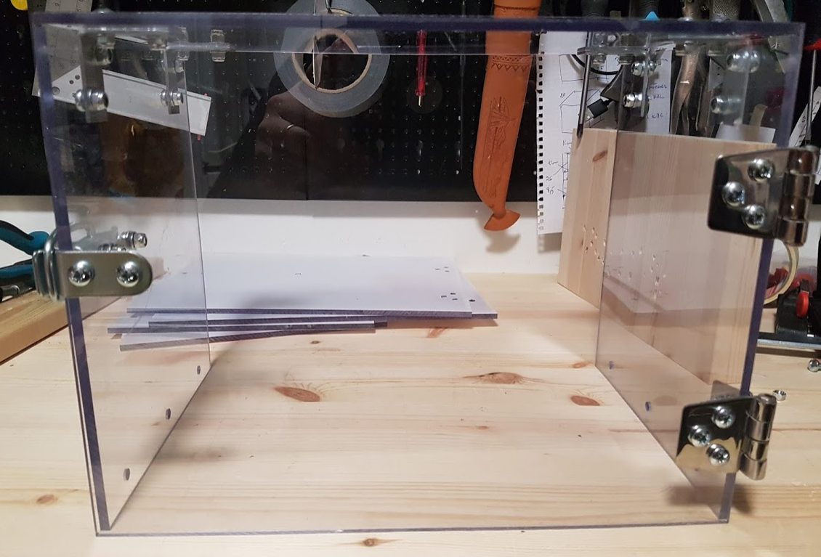

Adjust the lock mechanism to accommodate the bolt if needed.

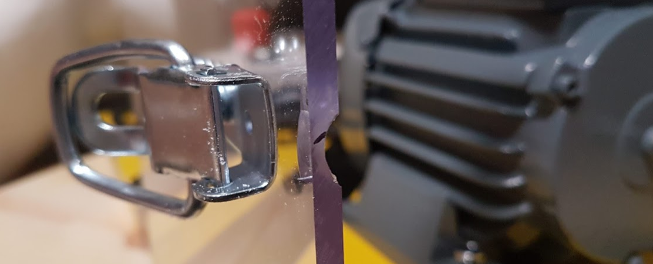

# Raspberry enclosure

Cut out holes for:

1. Led display 72x25 mm (front and center)
2. HDMI & Power cord 60x35 mm (Right side), about 18 mm from corner connecting to front and 5 mm from the bottom
3. 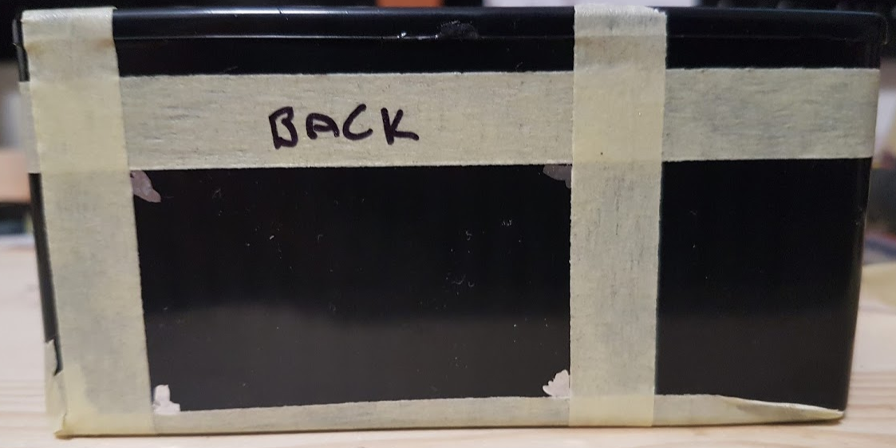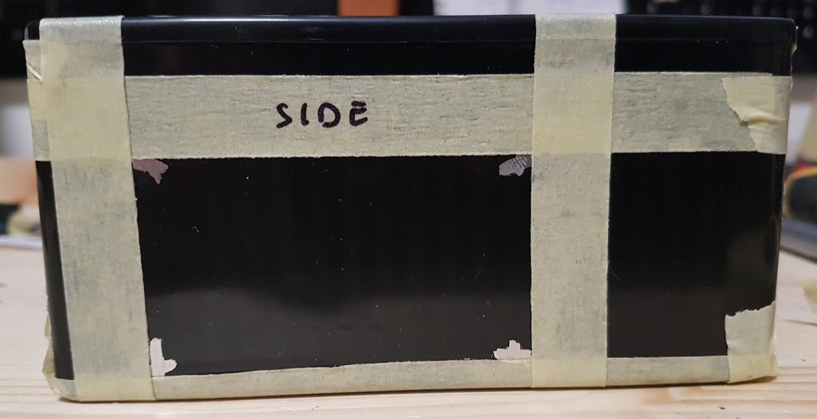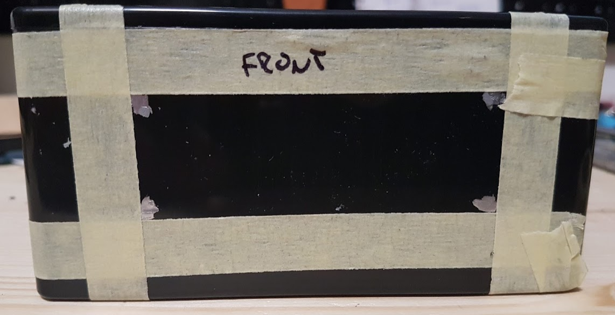Sensor wires and USB 60x35 mm (Back), about 18 mm from corner connecting to side and 5 mm from the bottom

Mark holes for Raspberry and use 2 mm bolts to mount it and the LCD display to the enclosure.

Leave clearance for sensor board and sensor wires. Use multiple bolts to leave clearance under

the raspberry to accommodate enclosure mounting screws.

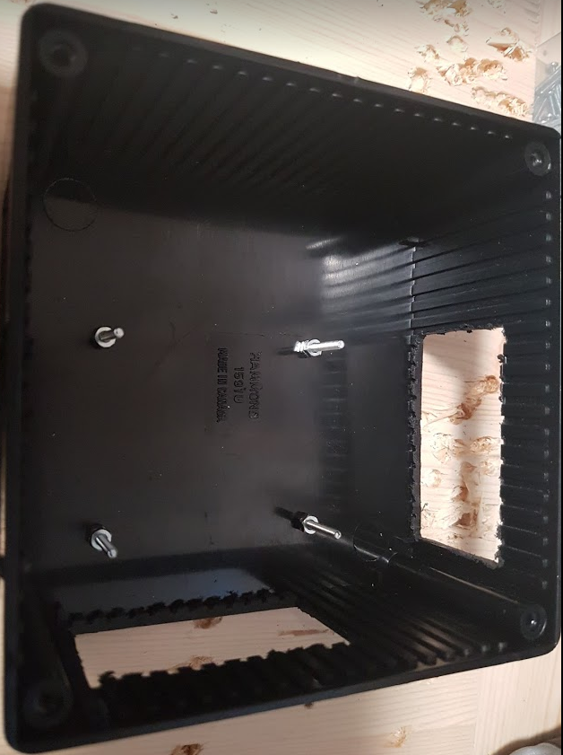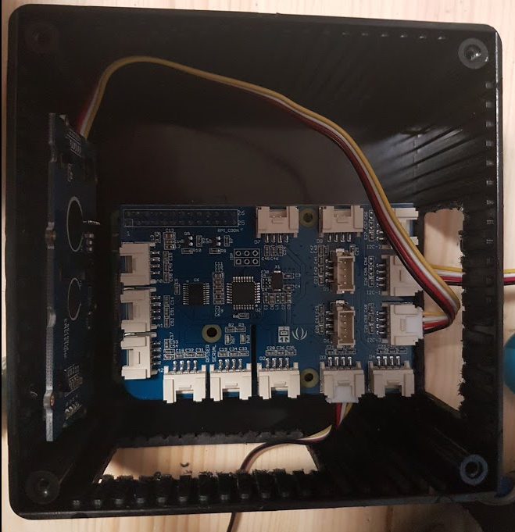

# Raspberry and sensor connections

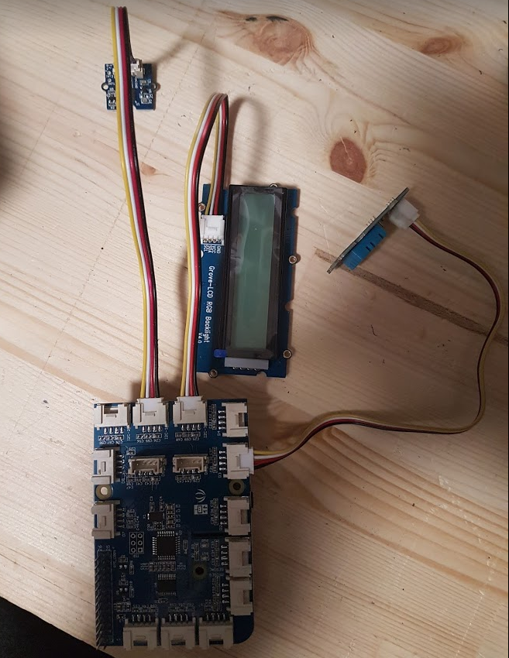

LCD display to I2C-3

Vibration sensor to I2C-2

Temp&Humidity sensor to D3

# Wooden board layout

Leave 10 cm loose on both ends of each cable for wire connections. So cut 480 mm and 540 mm wires. Condenser comes with connecting wire.

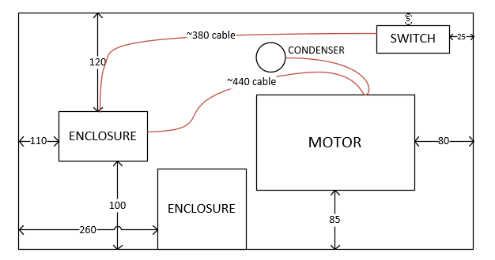

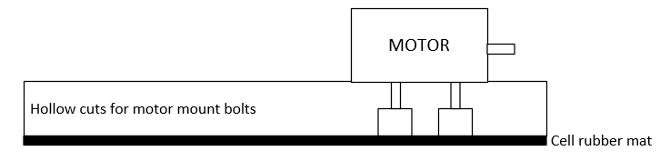

1. Place the components on the wooden board
2. Adjust the safety switch to cut power when motor enclosure is opened
3. Finally attach the cell rubber mat on the bottom of the wooden board
4. Attach sensors to motor
   1. Vibration sensor on the top and back of the motor
   2. Temperature and humidity sensor on the side and back of the motor

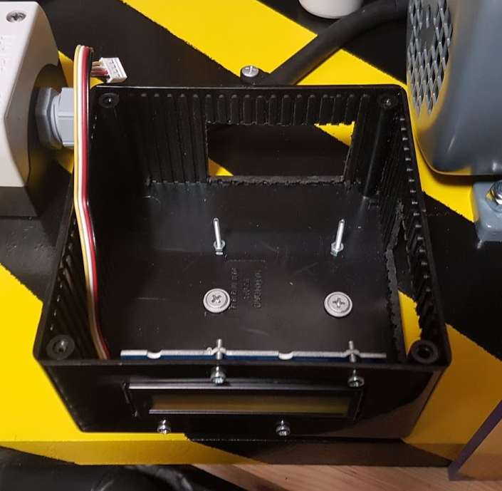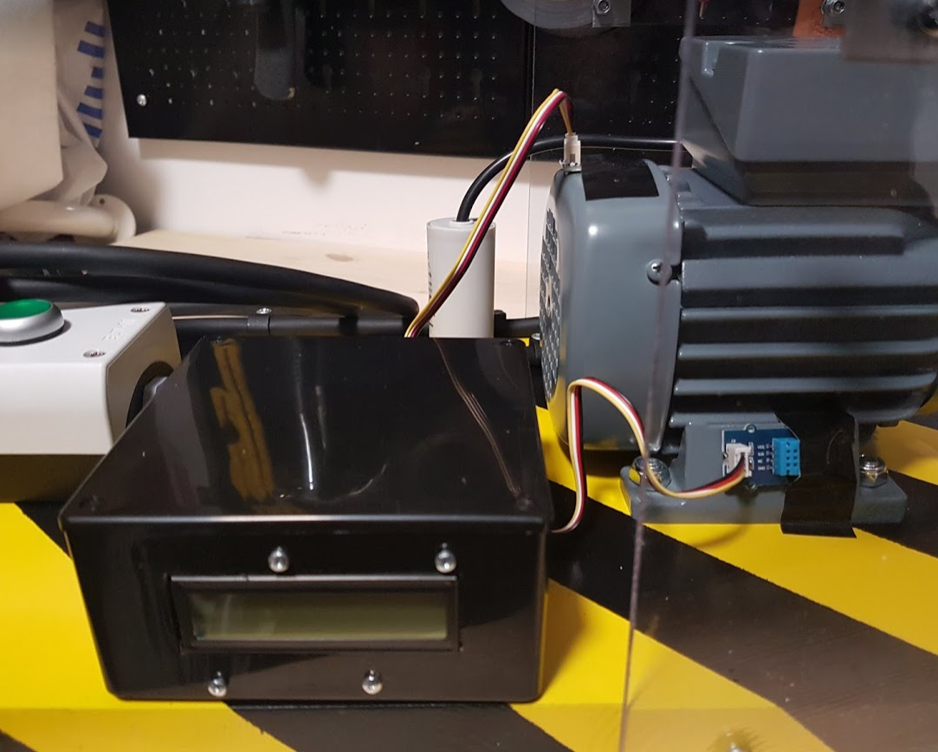

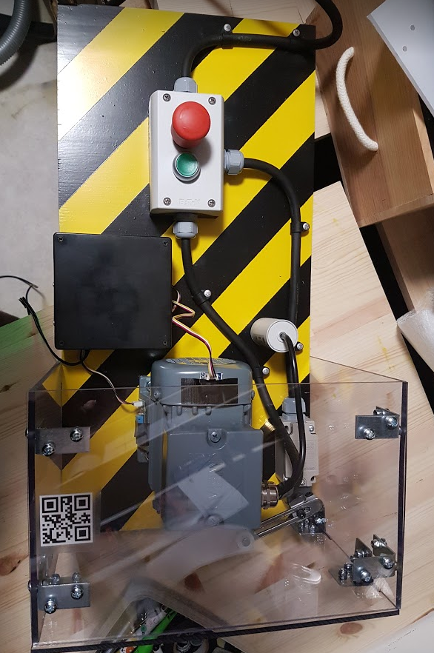

# Pulleys

Print pulleys with 3D printer using the model files

1. Working pulley (7 cm diameter)
2. Faulty pulley (7 cm diameter with peace broken off)
3. Wrong spare part pulley (5 cm diameter)

# Raspberry image

User : pi

Pw : arrowiot

Hostname : iotfactory

Deploy raspberry image file and configure WLAN & IoT hub connection string

1. Connect HDMI monitor and USB keyboard to raspberry
2. Login with username pi and password arrowiot
3. Run raspi-config

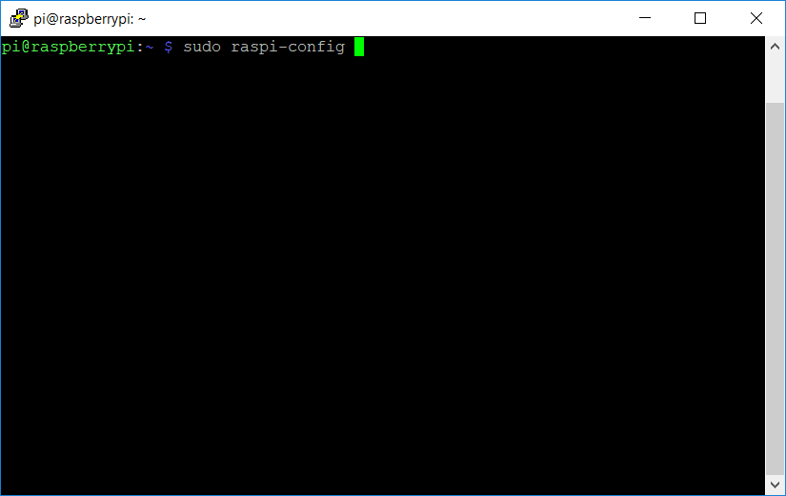

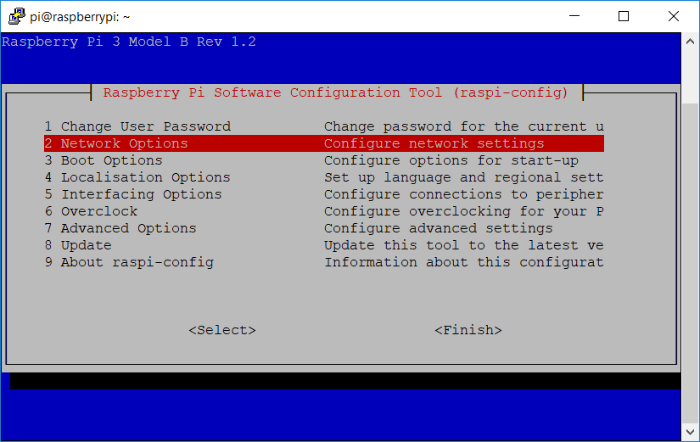

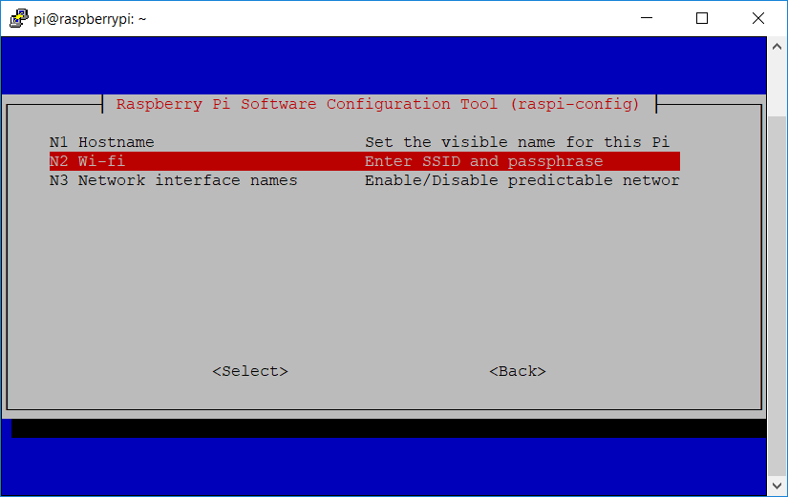

Setting up Remote Connection (SSH) on the Raspberry

1. Type in "raspi-config"
2. Select 4 - Interfacing Options
3. Select SSH
4. Select Enable SSH
   1. You'll now be able to ssh into the raspberry pi using a tool called Putty (available at <https://putty.org/>)
   2. In putty, type in the IP address of the Raspberry Pi and click on open to start creating the connection. You can sign in again with the same username & password.
   3. 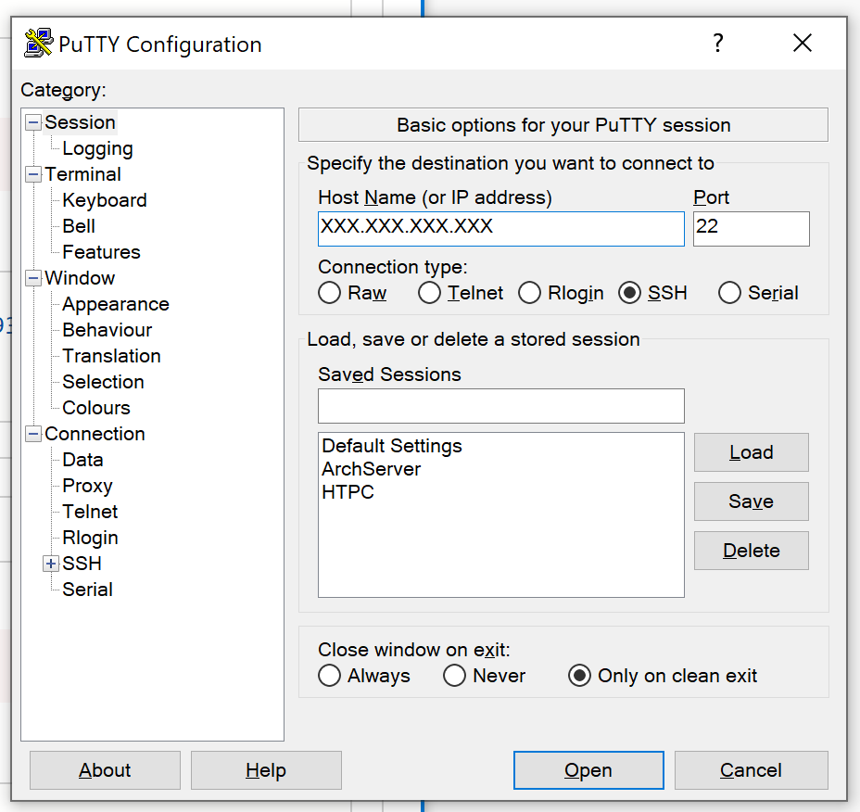

# Set Up Azure IoT Central & Create a New Device

1. Go to apps.azureiotcentral.com
2. Select "New Application"
   1. Select type "Pay-as-you-go" application (NOT trial since Microsoft Flow is NOT available during a trial)
   2. Select "Sample Devkits"
   3. Give in the Application Name, URL, Directory, Subscription & Region
3. After the application has been created, go to Device Explorer
   1. 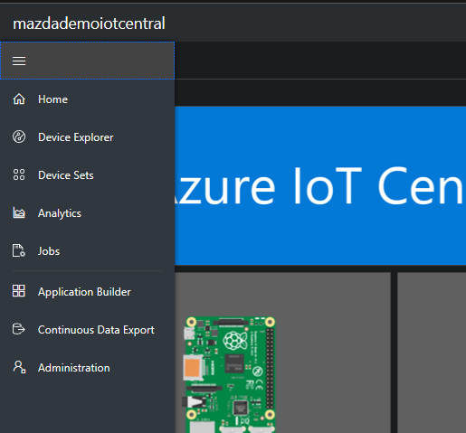
   2. Then add a new raspberry pi and click on "Create"

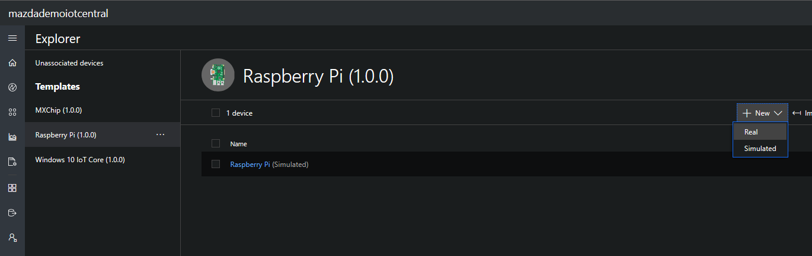

1. Generating the Connection String
   1. Go to the device you created (by clicking on its title in the list of devices) and click on the Connect button in the top right
      1. Note the Device ID, Primary Key & Scope ID
2. 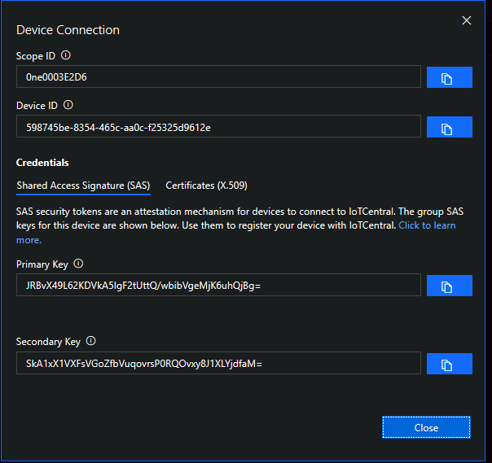
3. Configure iotcentral connection string
   1. edit file /iot/iothub_client_sample_tkn_CIE_rc_local.py
   2. edit line 63 starting with CONNECTION_STRING = "
4. Restart raspberry with “sudo reboot”
5. Your ip address should be visible in the display (DHCP must be available on the network)

Consider updating the sensor board <https://forum.dexterindustries.com/t/solved-dht-sensor-responding-1/2815/4>

Unzip the dsp_cstr zip to the desktop

* + 1. Open command prompt
    2. Run "cd Desktop"
    3. Run "dps_cstr.exe <scope_id> <device_id> <Primary Key>" (changing out the scope id, device is & primary key with what you noted before)
    4. Copy the connection string

1. 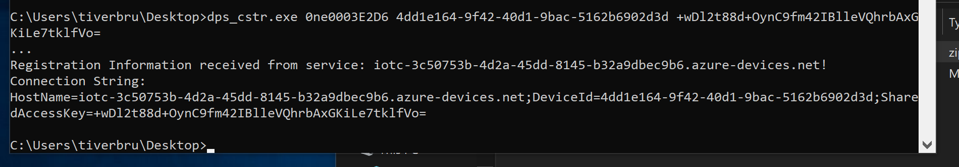

1. Adding the Connection string to the Raspberry Pi
   1. SSH into the raspberry pi
   2. Edit the following file by typing the command

"sudo nano /iot/iothub_client_sample_tkn_CIE_rc_local.py"

* 1. Edit line 63 starting with CONNECTION_STRING = "
     1. And add the connection string you copied before

1. Restart raspberry with “sudo reboot”

1. Your ip address should be visible in the display (DHCP must be available on the network)

# Attachments

All the software components can be found in the **Ext. MSFT FI Connected Field Service Project** teams site. General -> Files -> IoT Factory Documentation

|  |  |
| --- | --- |
| Raspberry image | iothub-10-12-2018.img |
| 3D model of working pulley | Working_Pulley_Cone_21_12_2018.stl |
| 3D model of broken pulley | Broken_Pulley_Cone_21_12_2018.stl |
| 3D model wrong pulley | WrongSparePart_Pulley_Cone_21_12_2018.stl |
| 3D fill model | 3DPulleys_FillDensity20_v2.gcode |
| QR code for motor | QR-Code.png |
| Documentation | IoT-Factory-Documentation-v2.0.docx |
| Accelerometer script (vibration) scripts.zip | basic_example_tkn_rc_local.py |
| Temperature and humidity script scripts.zip | grove_dht_pro_once.py |
| Iot Hub Client script scripts.zip | iothub_client_sample_tkn_CIE_rc_local.py |
| LCD display script scripts.zip | grove_rgb_lcd_tkn_rc_local.py |
| Init.d script to start ip script | getip |
| Init.d script to start iothub client script | iothub |
| Init.d script to start vibration script | vibration |

# Version history

|  |  |  |  |
| --- | --- | --- | --- |
| Version | Date | Name | Comment |
| 1.0 | 4.12.2018 | Tuukka Korhonen | Document creation |
| 1.1 | 5.12.2018 | Tuukka Korhonen | Added Rasb Model and sensor SKUs |
| 1.2 | 7.12.2018 | Tuukka Korhonen | Updated some screw and bolt lengths |
| 2.0 | 21.12.2018 | Tuukka Korhonen | Version 2.0 |